**INFOLABZ IT SERVICES PVT. LTD.**

**Internship :** React Js / MERN stack

**Session No :**

**Topics to be covered :** Getting Started with bootstrap, Tables

Bootstrap CDN links :

<!-- Latest compiled and minified CSS -->

<link rel="stylesheet" href="https://maxcdn.bootstrapcdn.com/bootstrap/3.4.1/css/bootstrap.min.css">

<!-- jQuery library -->

<script src="https://ajax.googleapis.com/ajax/libs/jquery/3.7.1/jquery.min.js"></script>

<!-- Latest compiled JavaScript -->

<script src="<https://maxcdn.bootstrapcdn.com/bootstrap/3.4.1/js/bootstrap.min.js>"></script>

Bootstrap Classes :

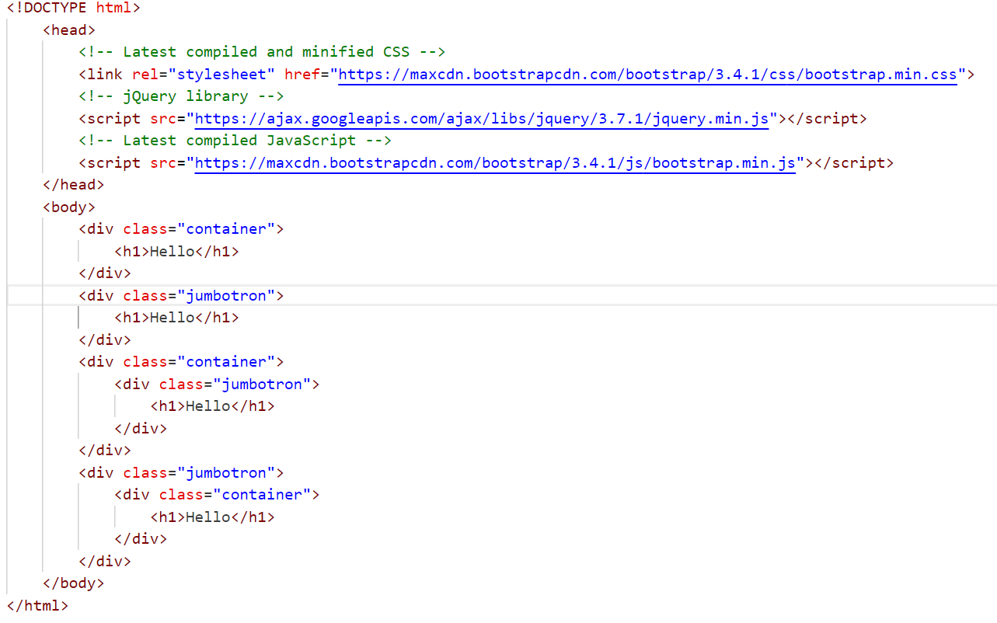

Bootstrap Rows , Cols and Grids : ( MIMP )

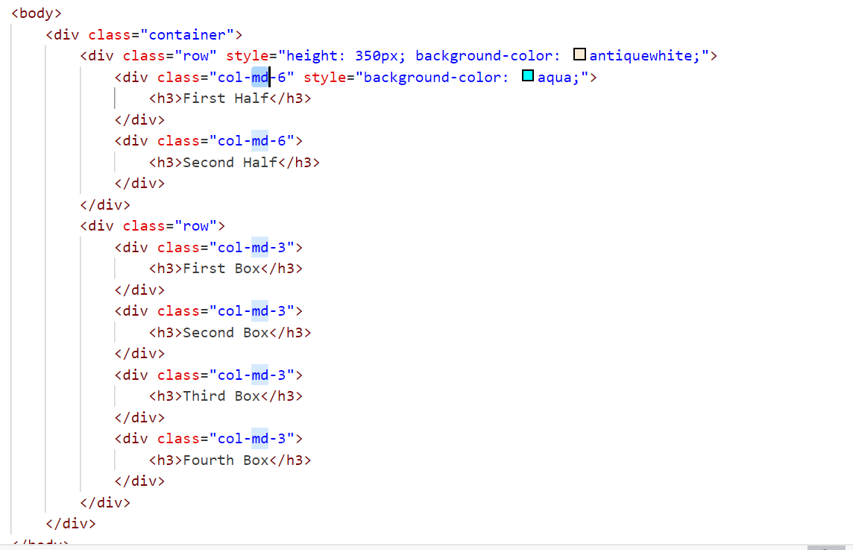

TOPIC 1 : Bootstrap Tables :

1. Apply table class in normal html table
2. Create Stripped table
3. Create Howerable table
4. Create Table with stripped + hover + border class

Print table as per following output :

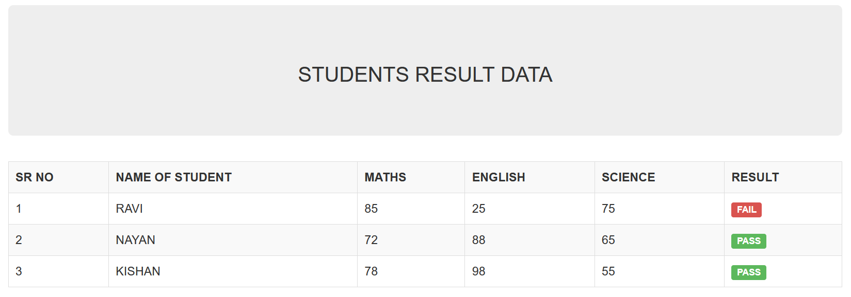

TOPIC 2 : Bootstrap Buttons

TOPIC 3 : Bootstrap Badges

TOPIC 4 : Bootstrap Slider

1. Image
2. Image with caption title, description and bottom control

TOPIC 5 : BOOTSTRAP FORMS

1. Create login form
2. Create form with Name, Email, Password, Confirm Password , Gender ( Radio ) , City ( Dropdown ) , Address ( TextArea ),Agree to terms and conditions (CheckBox).

TOPIC 6 : Bootstrap Navbars

1. Create navigation bar with following hyperlinks and content
   1. Logo
   2. Menu ( Home, About, Services, Portfolio, Contact Us )
   3. Login & Sign Up button

TOPIC 7 : Bootstrap Cards

Create a card group with 3 cards in a row with following details.

Movie Image, Movie Title , Movie Short Description, Genre and Release Date

TOPIC 8 : Bootstrap Models

1. Open a model on click of the button
   1. Change width of model
   2. Model should be vertically centered ( open in center of screen )
2. Add a form inside model.
3. Add a table inside model.

Master Task 1 : Adding form data in table rows.

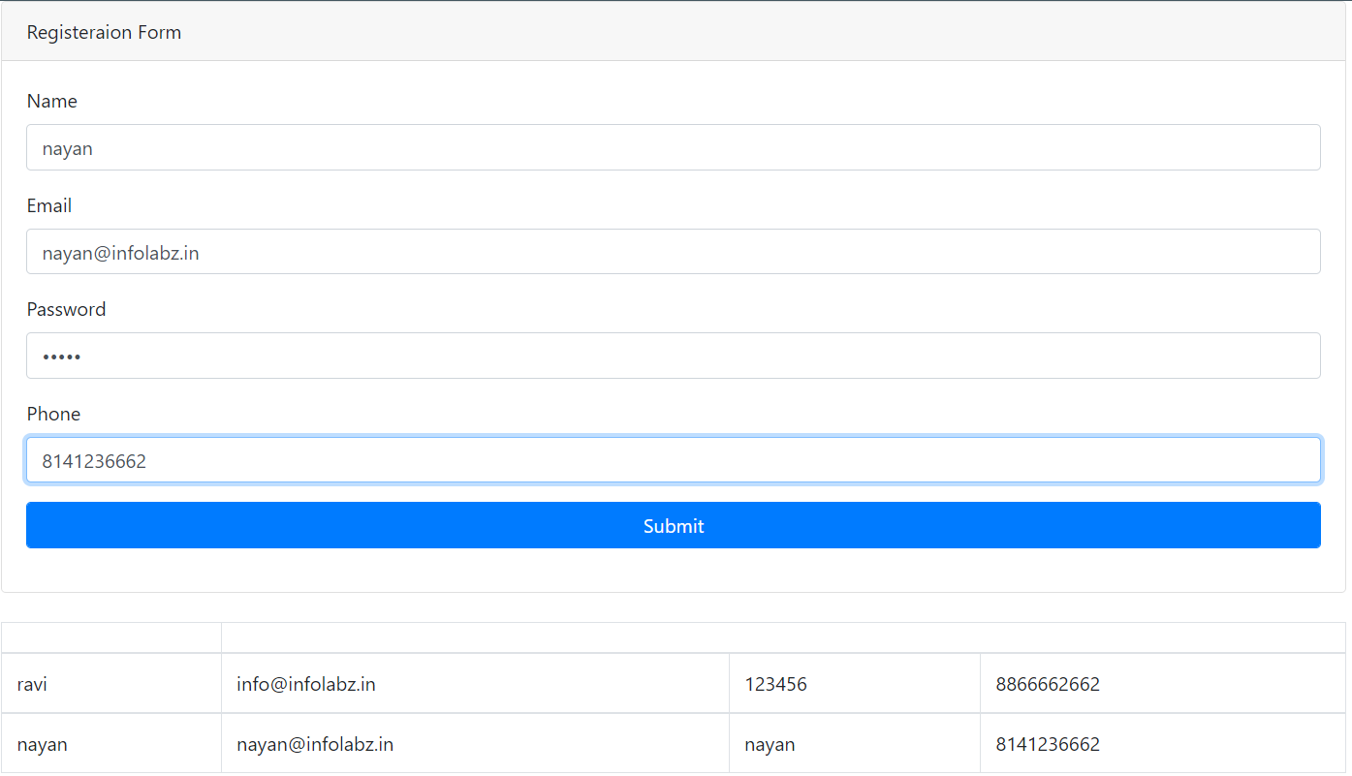

Master Task 2 : Create a registration form with following conditional output. Based on checkbox is checked or not.

Output 1 :

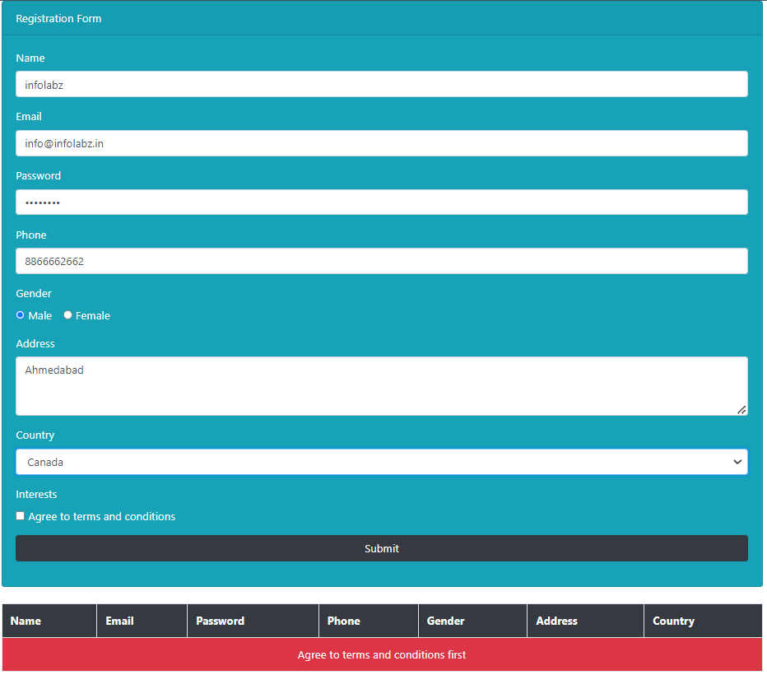

Output 2 :

